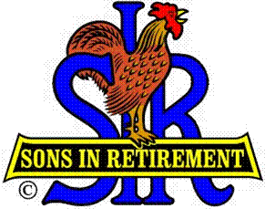

Las Trampas Branch 116

Executive Committee Meeting Agenda

August 21, 2017
10:45 AM
- Call Meeting to Order and confirm we have a quorum.
- Review Agenda/Minutes for Changes/Additions.
- Standing Reports:
Secretary – Fred Schafer – Approval of July 17, 2017 minutes.
Attendance – Sam Beret
Head count, missed luncheon receipts.
Membership – Phil Goff
New Members to be inducted:
Guests Today:
Visitors:

- Budget – Jim Nickles

- Big Sir Report:
- Storyteller: Michael Barrington
- Chaplain: Matt Arena
- Annual Corporate Meeting – August 8, 2017.

- Little Sir Report:
- July Speaker: David Ainsworth – SS Jeremiah O’Brian
- August Speaker:
- Other

- Other Reports

- Adjourn – 11:00 am

